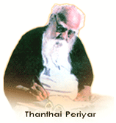
PERIYAR UNIVERSITY

Periyar Palkalai Nagar
SALEM - 636 011

No Dues Certificate for Synopsis/Thesis Submission
(For University Departments only)

- Name of the Candidate :
- Name of the Supervisor :
- Name of the Department :
- Name of the Course :
- Signature of the Candidate :
- Supervisor :
- Department Library :
- Head of the Department :
- University Library :
- Hostel (Boys / Girls) :
- Finance Officer :
- Research-Coordinator :

